Please use the Data.xlsx file to investigate the effect of independent variables (price per square foot, number of bathrooms, and floor size) on the price of a high-floor, spacious 2-bedroom house with a spectacular view, available at an affordable price. The null hypothesis (H0) states that there is no significant effect of the independent variables on the price. The alternative hypothesis (H1) suggests that there is a significant effect of the independent variables on the price. The objective is to test this hypothesis using the provided data in the "Data" Excel file.

# CAPSTONE - 2

.

1. Selection of Confidence Level: A 95% confidence level is chosen to determine the range within which the true parameter value is likely to fall. A 95% confidence interval covers 95% of the normal curve, meaning that there is a 5% probability of observing a value outside of this range.
2. Statistical Test or Model: To test the hypothesis, a multiple regression analysis is conducted. This analysis helps determine the relationship between the dependent variable (price) and the independent variables (price per square foot, number of bathrooms, and floor size).

**Solution:**

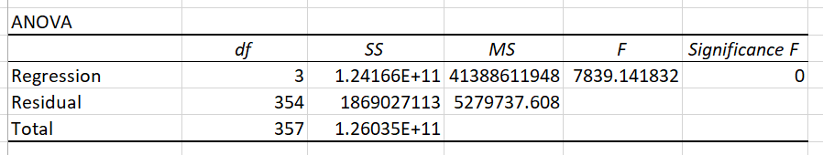

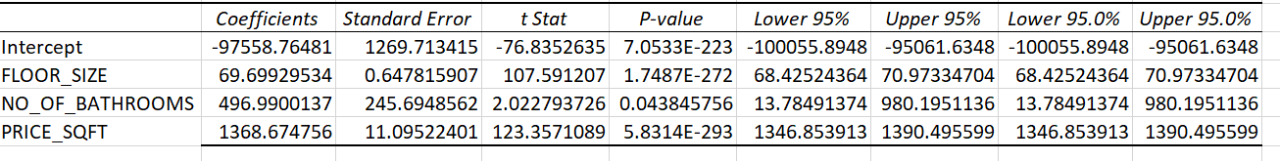

**Result:** Floor Size, Number of Bathrooms, and Price per Square Foot all have statistically significant effects on the house price.

The p-value is a measure used in statistical hypothesis testing to help you determine whether to reject the null hypothesis. In simpler terms, it helps you assess the strength of the evidence against the null hypothesis. Here’s a basic rundown:

* **Null Hypothesis (H₀)**: The default assumption that there is no effect or no difference.
* **Alternative Hypothesis (H₁)**: The hypothesis that there is an effect or a difference.
* **P-value**: The probability of obtaining test results at least as extreme as the ones observed, assuming that the null hypothesis is true.